An issue

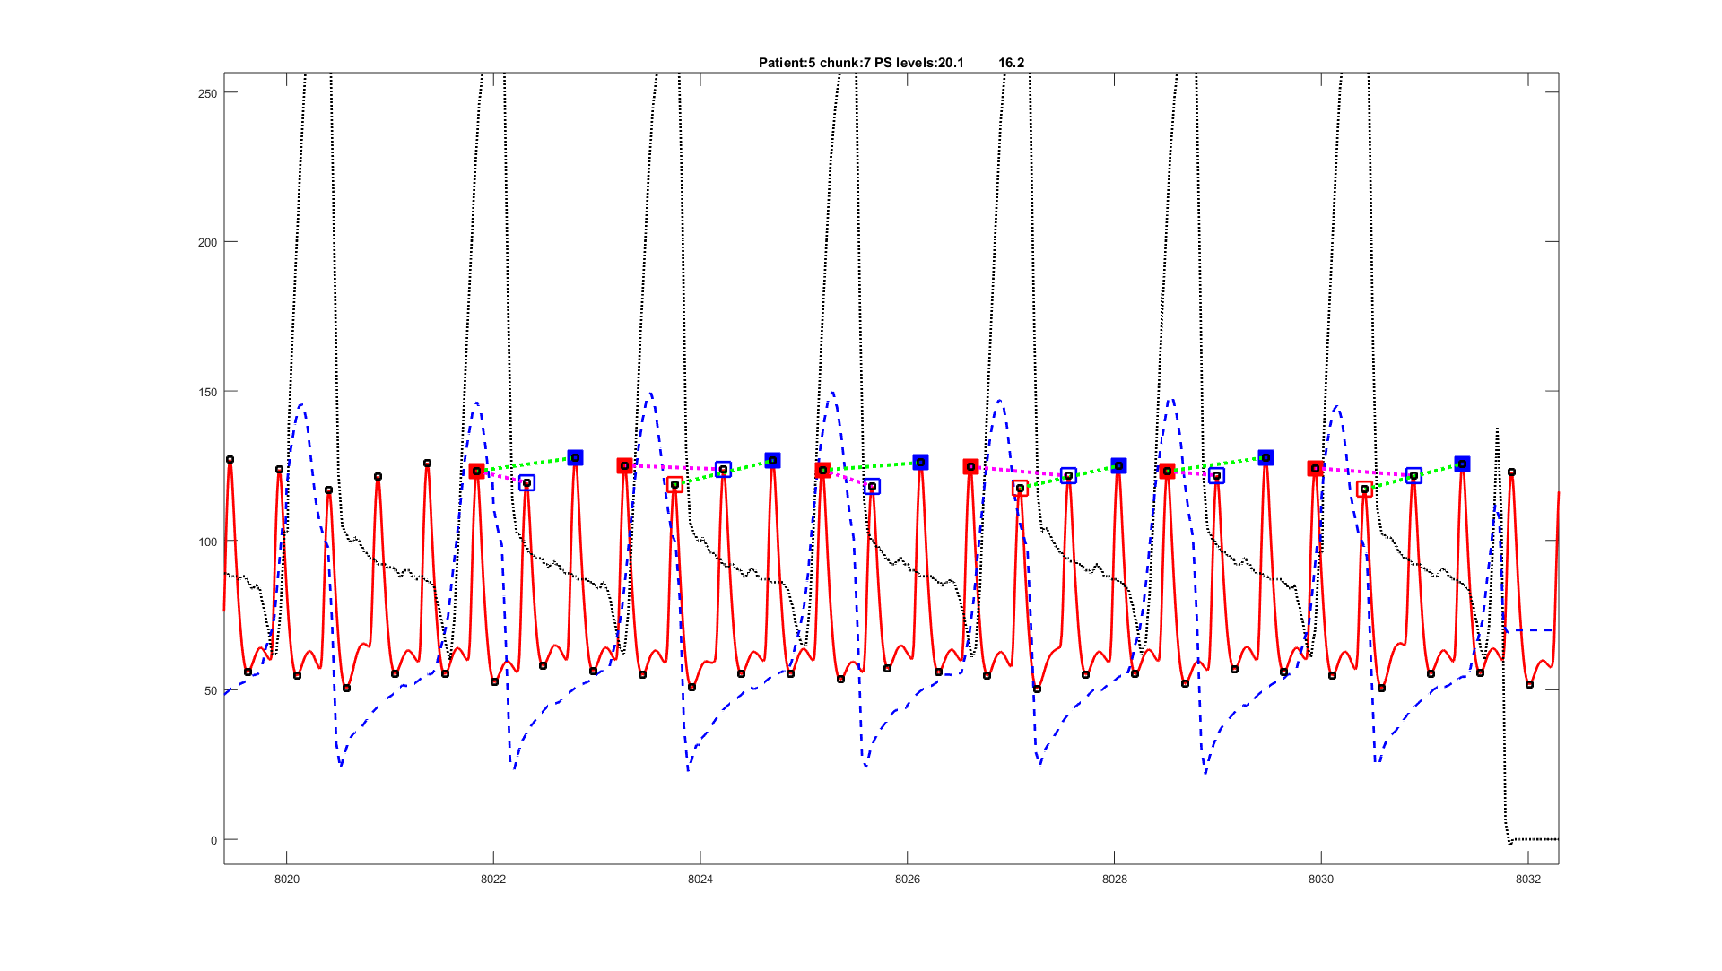

In patient 5 the patients systolic clearly increases on expiration and is then depressed on inspiration, thi scan be better seen without some of the symbols

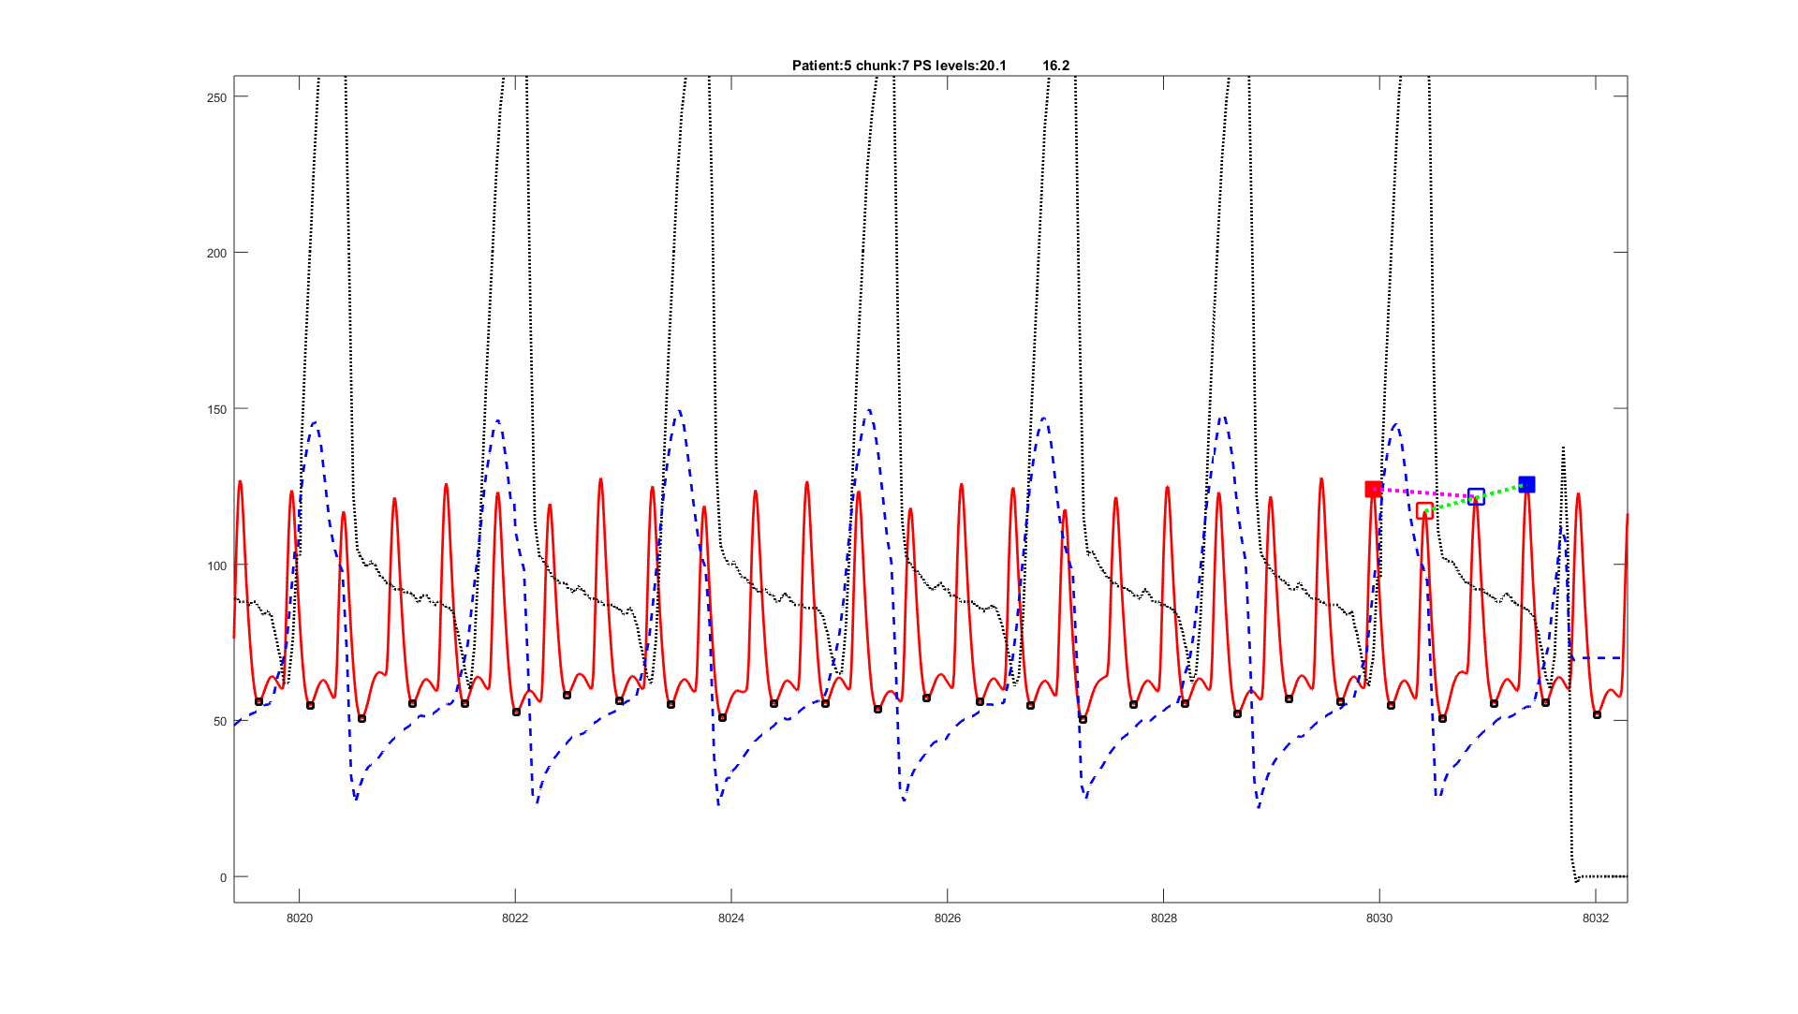

The problem is that the release due to the inspiration and falling systolic is not completely over when the expiration starts, so that it looks like we have a low minimum on the expiration, where in reality it is only due to the inspiration.